Personal data

Name and initials:
First name:
Sex: M / F
Address:
Postal code and City:
Phone number:
Emergency number:
e-mail:
Date of birth:
Institution: TU/e / Fontys Hogeschool Eindhoven / other¹:
Sports card number:
IBAN number:
Account holder:

Registration

By signing this form, you agree with registration at E.S.W.V. Squadra Veloce. The membership fee wil be €92 per year and the membership will normally be prolonged by 1 year every year.
With this membership, you will get access to the trainings which will be given by E.S.W.V. Squadra Veloce in the triathlon program and you will get an NTB licence.

Have you already got one of these licenses? Please fill out your license number below:
KNWU:
NTB:

Annual re-registration

I hereby authorize the board of E.S.W.V. Squadra Veloce to prolong my registration annually, unless I cancel my registration before the end of the year by e-mail.
The board will send a reminder before the end of the year to ask if you want to cancel your registration at E.S.W.V. Squadra Veloce.

Name: Date:

Privacy

I hereby agree that E.S.W.V Squadra Veloce can use my personal details to create a membership.

Do you want to be added to the WhatsApp group from E.S.W.V. Squadra Veloce.
- Yes please
- No thanks

Name: Date:

Place: Sign:

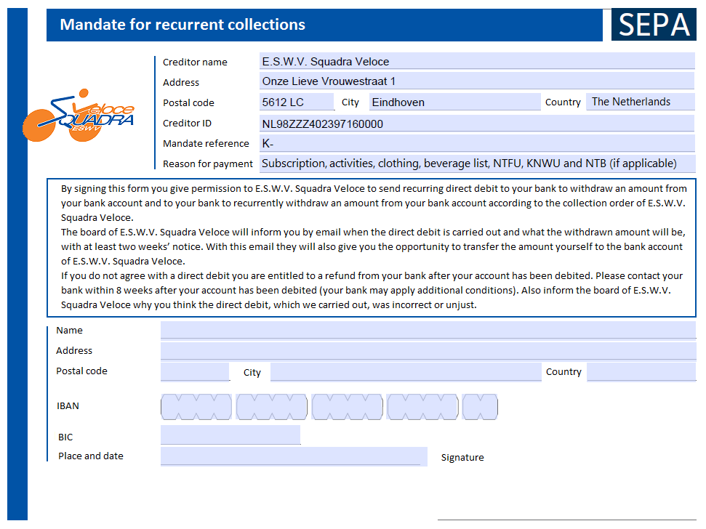
City: Signature:

Strike through which is not applicable
A year will be from January 1st until December 31st.

